ECOM APP

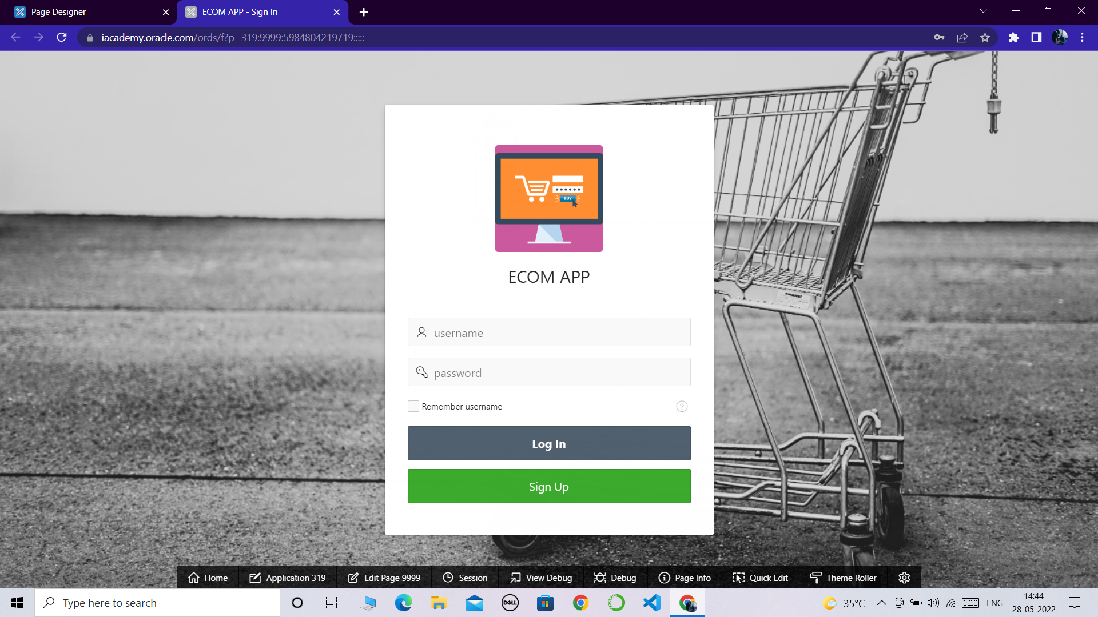

**STEP-1:** *The user will enter into the login page immediately after opening the ecom web app.*

**STEP-2:***click on SIGN UP button to register if your a new user.*

*if you are an existing user then use your username and*

*password to LOGIN into the ecom app*

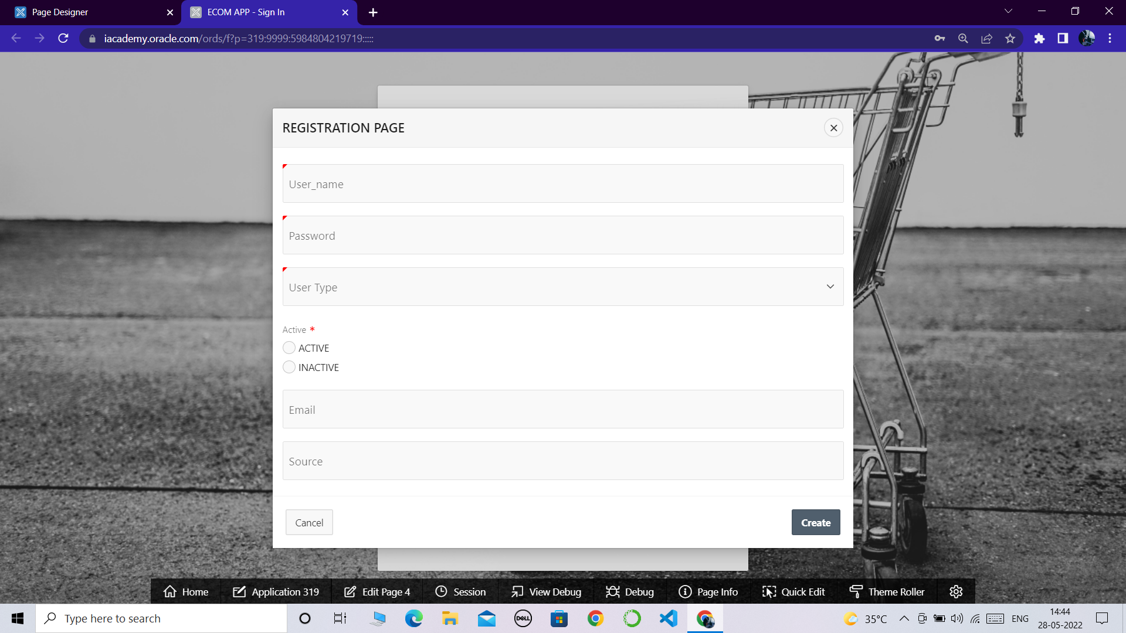

**STEP-3:** *when you click on the SIGN UP button you will be redirected to registration page.*

**STEP-4:** *Enter you credentials in the registration page such as*

*->username*

*->password*

*->user type*

*->active status*

*->email*

*->source*

**STEP-5:***then click on create*

*your registration will be succesfull*

*use the credentials to login into the ECOM App*

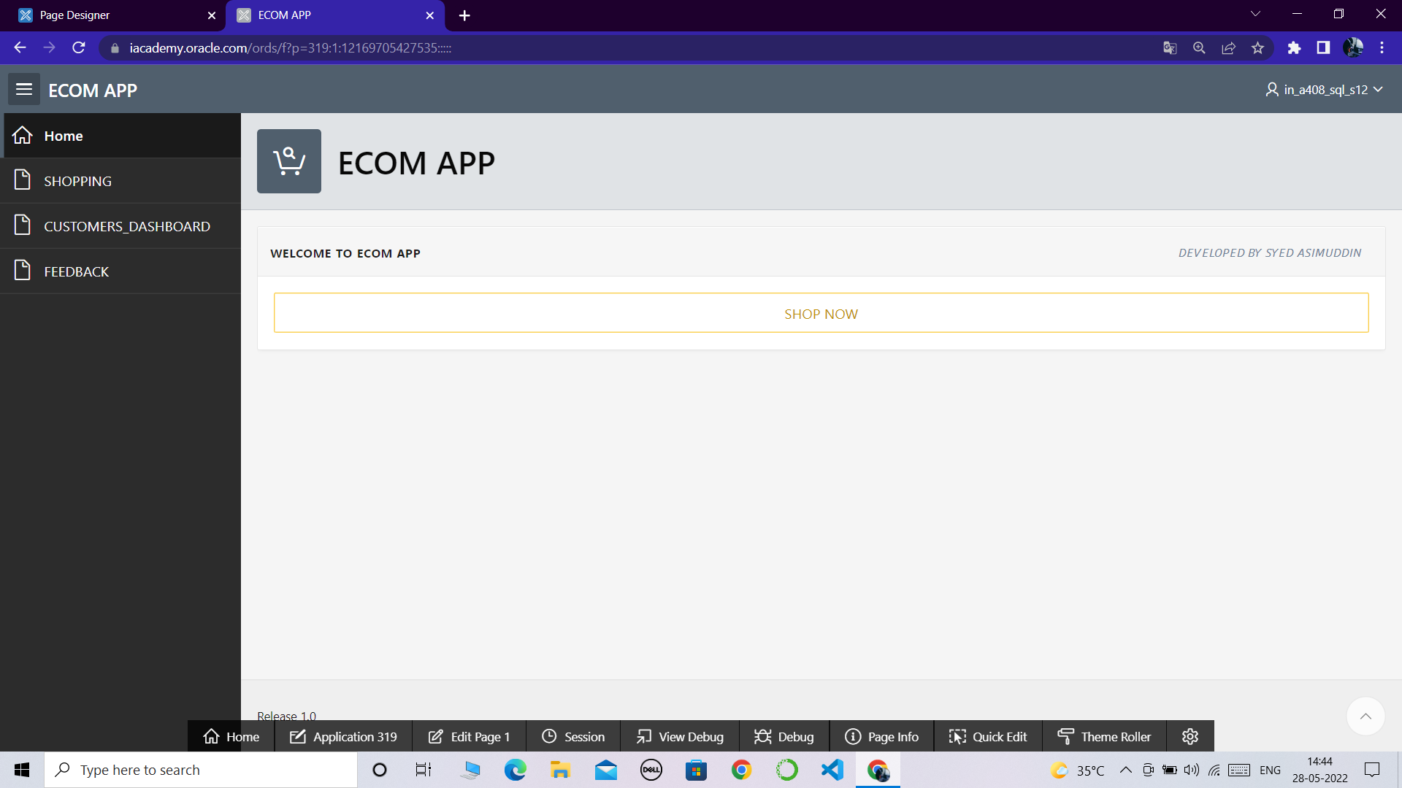

**STEP-6:***after you logged in into the app the above interface will be appeared with home page*

*welcome to ecom app*

**STEP-7:***now click on shop now button then you will be redirect to the shopping page*

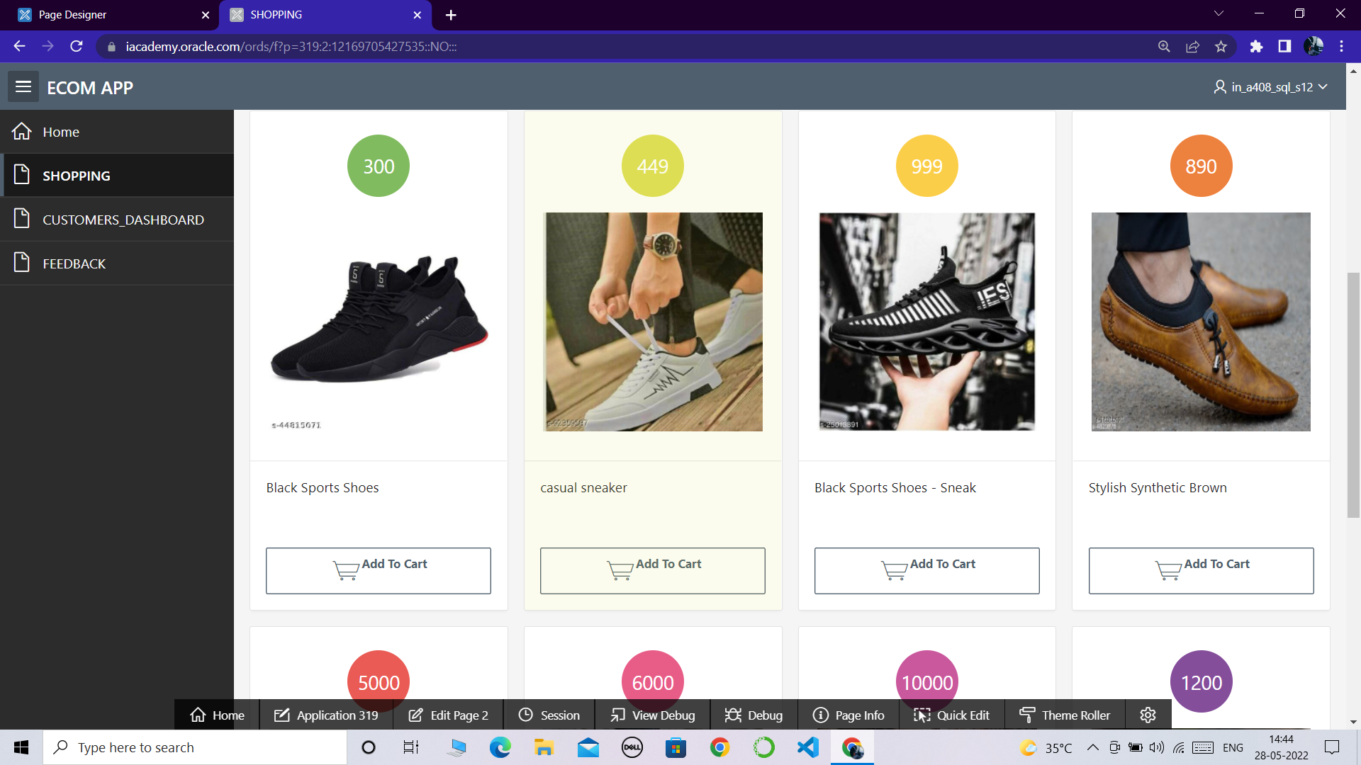

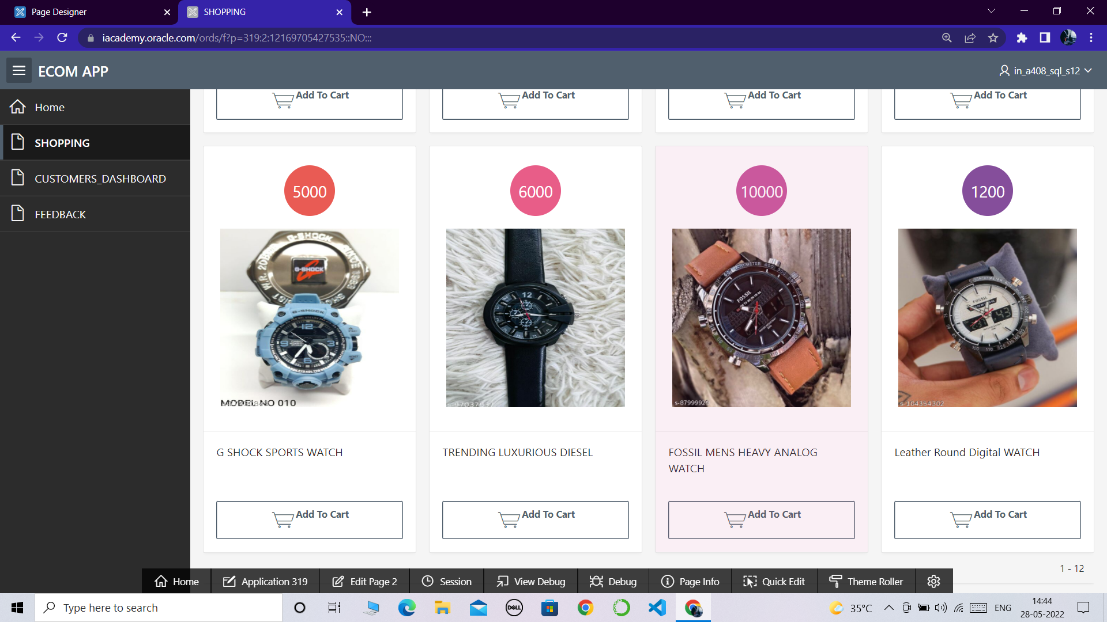

**STEP-8:** *wide range of clothing and style products will be visible in the shopping page*

**STEP-9:***click on add to cart button on any product you like and wanted to order it*

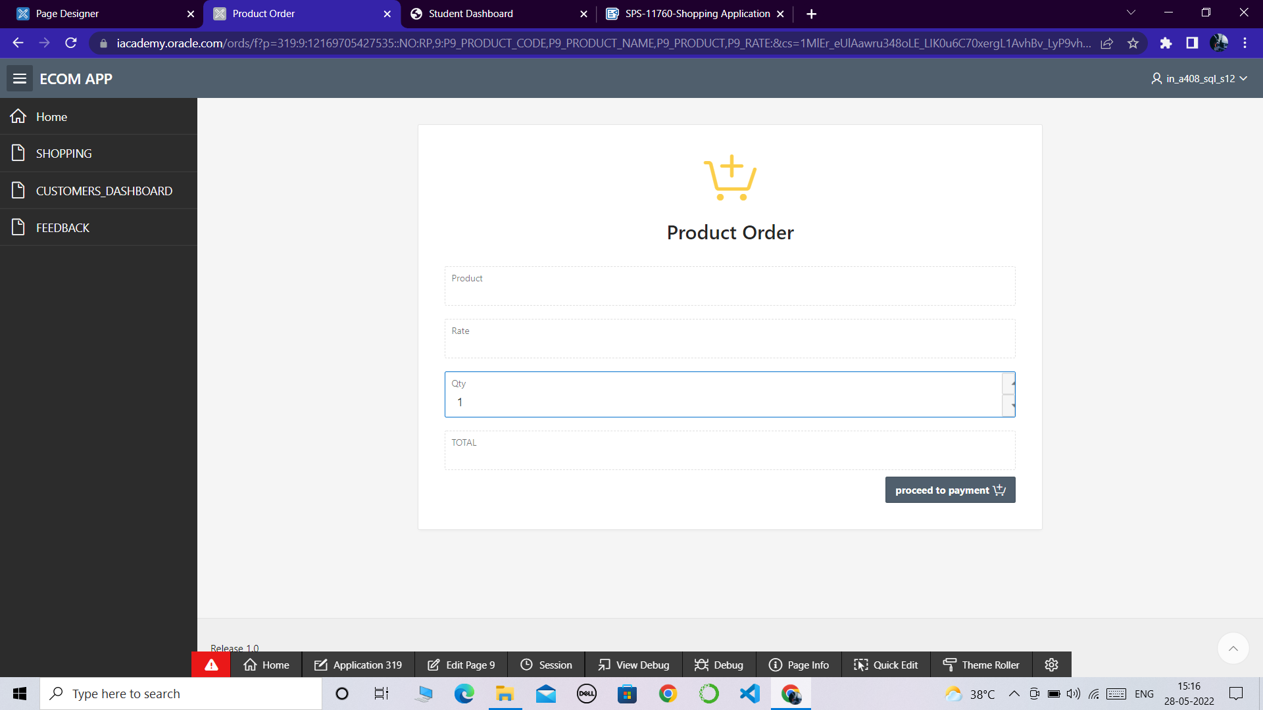

**STEP-9:** *select**the**quantity you want and then click on the proceed to payment button to checkout your order*

**STEP-10:** *enter all your adreess details and also select the payment method in the form then click on place order to place and confirm your order*

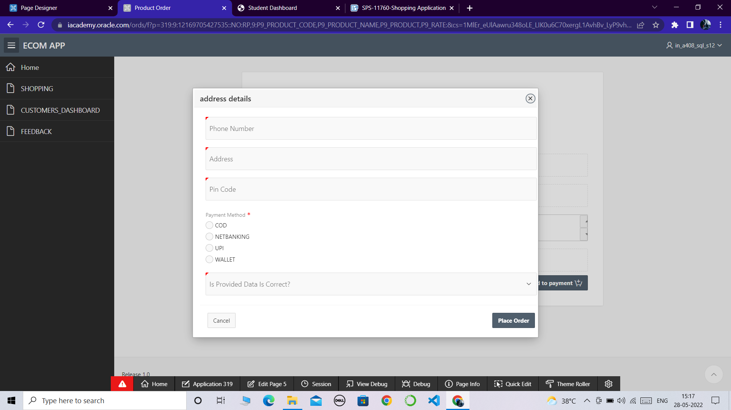

**STEP-11:** *when you click on the place order your order will be confirmed and placed*

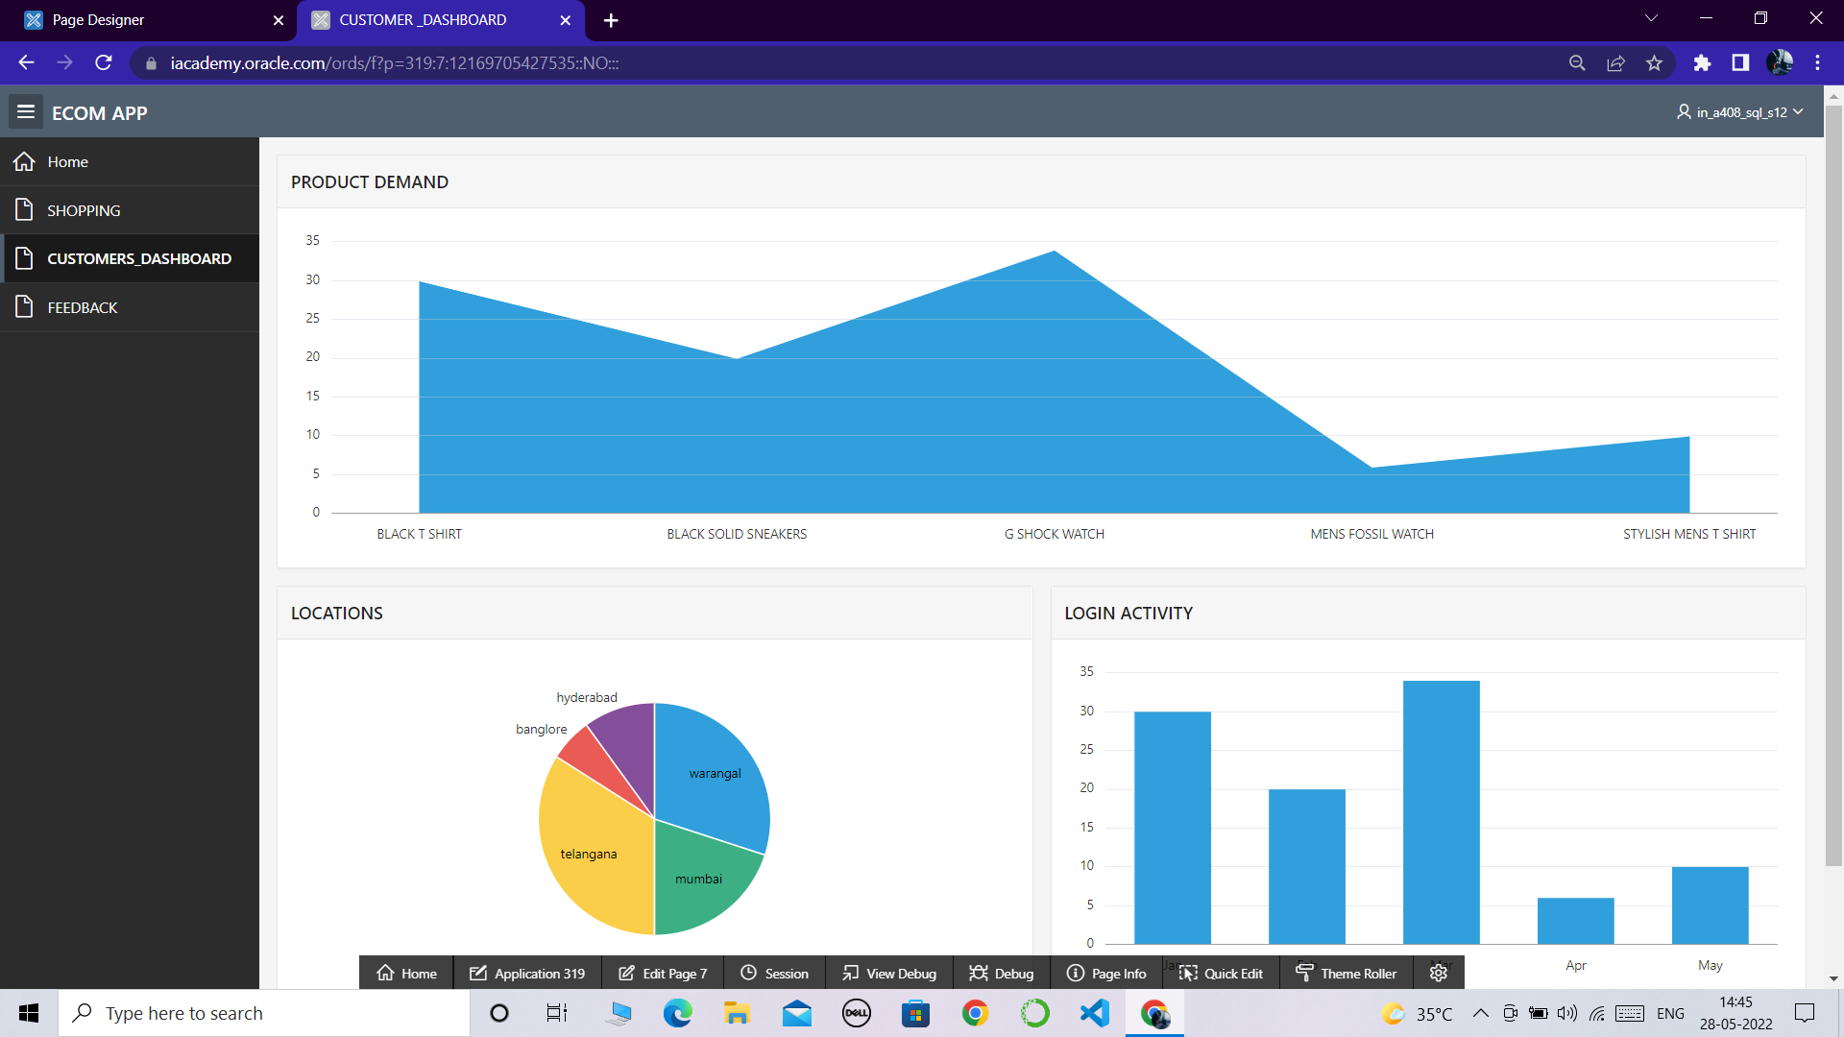

**STEP-12:** *click on customers dashboard to check the customer stats*

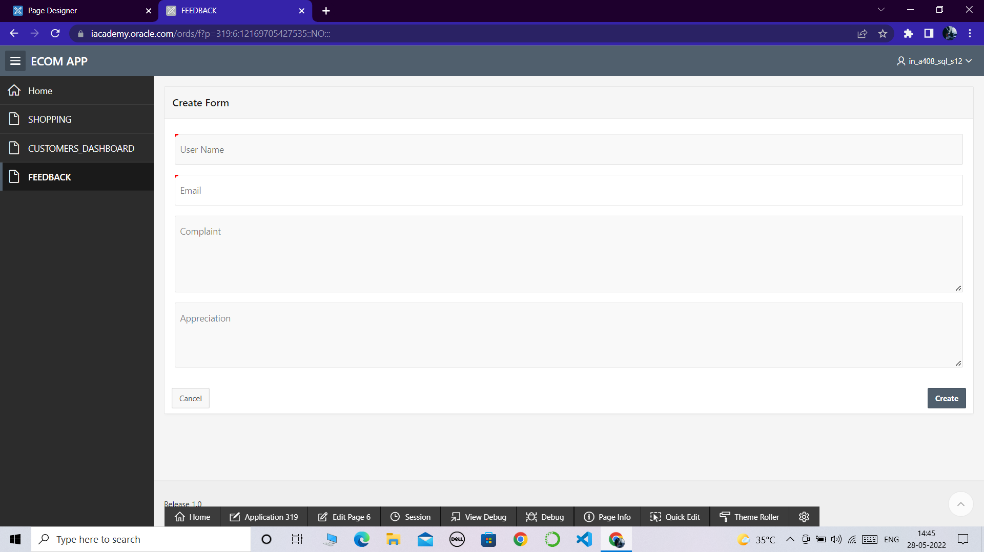

**STEP-13:***click on feedback for any kind of complaints or appreciations*

**THANK YOU!!!**